Wearable Stress Detection using Empatica E4

CIS4006-N Advanced Practice
Group Report

Module Leader: Anna Huber
Module Supervisor: Christopher Thornton

Group Members
- Karan Desai (S3529053)
- SaiRam (S3531250)
- Mohan (S3534961)



Teesside University
Middlesbrough, England
United Kingdom

Submission Date: 05/05/2026

Introduction

Wearable devices are really important for keeping an eye on our health and seeing how we behave. These devices let us keep track of what's going on in our body all the time even when we are just doing our daily things. Our body sends out signals that can tell us a lot about how we're feeling both physically and emotionally. One cool thing that wearable devices can do is detect when we are stressed. Stress is not good for us it can hurt our body and mind so being able to detect it can really help us stay healthy.

The goal of this project was to look at the signals from a device to see if we can find patterns that happen when we are stressed. We used a device called the Empatica E4 to collect our data. This device records a lot of things like how much we sweat our heart rate, our skin temperature and how we move around. All these things can change when we are stressed.

We worked on this project in a group. Each person did a different part. We broke it down into three parts: looking at the data and making labels making the signals into something useful and using computer models to figure out when we are stressed. The first part was about understanding what we had and making labels for when we were stressed and when we were not. The second part was about taking the signals and turning them into something that meant something. The third part was about teaching the computer to use these things to tell when we are stressed.

By putting all these parts, we wanted to make a system that could take the signals from the wearable device and use them to detect stress. We used the Empatica E4 device to collect physiological signals like electrodermal activity, heart rate, skin temperature and accelerometer data. These physiological signals from the Empatica E4 device are really important, for detecting stress.

Dataset Description

The data we used for this project came from people who wore the Empatica E4 device. Each person had a folder with lots of files that showed things about their body. These files had information about how sweaty their skin was, their heart rate, temperature and how they were moving around. There was also a file with tags.
Each of these files was set up in a way. The first line said when the recording started. The second line said how often the data was collected. The rest of the lines had the data. Since each type of data was collected at a rate, we had to change it so that it was all based on time. This way we could line up all the data correctly.
The tags file had timestamps that showed when the person was stressed. We used these timestamps to label the data as either rest or stress. Normally all the data was labeled as rest. The parts that matched the timestamps were labeled as stress.
It was really important to understand how the data was organized. This way we could work with it correctly on. We had to get this right so that the rest of the project would work out okay. The Empatica E4 device data was the key, to the project so we had to make sure we understood the Empatica E4 device data.

Data Preprocessing and Label Creation

The first stage of the project was about checking the data and creating labels.
We took the physiological signals loaded them and turned them into data frames that were organised by time. To do this we had to find the start time and sampling rate of each file and create a time index, for the values.

Because the signals were recorded at rates changing them into time-based data frames helped us align them using timestamps. This made sure that we could study signals from sensors together at the same time. The signals could now be. Analysed as they happened at the same time intervals.

Next, we used the tags file to make labels for the signals. Each pair of tag times showed when a stress interval started and ended. We used these intervals to label the signals as either rest or stress.

By doing this labelling we ended up with a dataset where each piece of data had a physiological signal value and a label that said if it was a rest or stress condition. The physiological signals were. Labelled to create the dataset.
This dataset had signal values and their corresponding rest or stress labels.

Feature Engineering

Physiological signals are like a stream of data that goes on and on. This makes it really hard to use them with machine learning models. So we had to break the signals into bits to make them work. We did this by using something called sliding window segmentation. We took the signals. Broke them into smaller pieces that were all the same length. Each piece is like a snapshot of what was happening at a time. We tried using lengths for these pieces:
- 10 seconds
- 30 seconds
- 60 seconds
By trying out different lengths we could look at the physiological signals in different ways.

We made the pieces overlap a bit so one piece would start before the other one ended. This helps the pieces fit together smoothly. Gives us more pieces to work with. For each piece we looked at some numbers that tell us about what the signal was doing during that time. These numbers are like a summary of what was happening. The main numbers we used were the average and how spread out the numbers were.

We looked at things like the electrodermal activity and how spread out the electrodermal activity was. We also looked at the heart rate and how spread out the heart rate was. We did the thing with skin temperature and the movement of the accelerometer.
The accelerometer was originally measuring movement in three directions (X, Y, Z). We combined these into one number that tells us how movement there was overall. We did this using a formula:
Magnitude = √(x² + y² + z²)

We also gave each piece a label based on what was happening during that time. This label is, like a tag that tells us what the signal is saying. Physiological signals are used to figure out what the label is. We used signals to make the labels. The labels are based on signals.

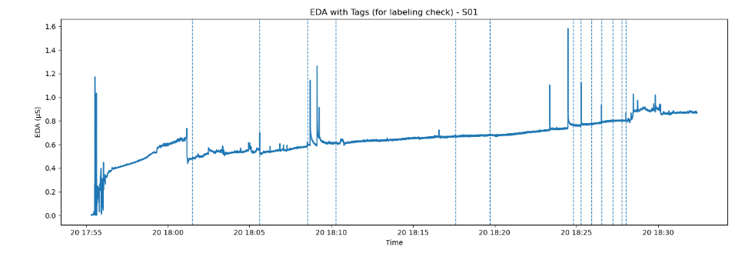

Feature Dataset Creation

After extracting features from each sliding window, the results from all participants were combined into one feature dataset.
Each row in this dataset represented a sliding window segment with its features and label. The dataset had the following information:
- Subject ID
- Window size
- Extracted features
- Label, which was either rest or stress
The dataset was saved as a CSV file for easy reuse in the machine learning stage.
Creating a feature dataset was crucial because it helped turn raw physiological signals into useful features for analysis and classification of the physiological signals and the features.
The feature dataset was a part of the project.
It allowed for analysis and classification of the data.
The data was now ready, for machine learning.

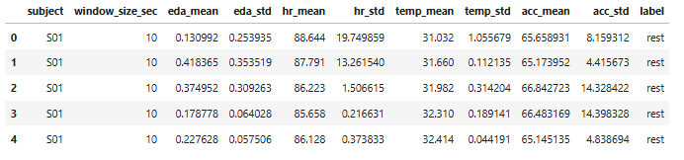

Statistical Analysis

I wanted to learn more about how people react when they are resting and when they are stressed. So, I did some work with numbers to see what I could find out.

First, I looked at each person one by one. Calculated their average responses when they were resting and when they were stressed. This way I could see how each person reacted individually.
Next, I made some pictures called boxplots to see how the signals from people’s bodies were different when they were resting and when they were stressed. I made these pictures for things like how they were sweating their heart rate and their body temperature. These pictures really helped me see the differences between when people were resting and when they were stressed.

Finally, I did some tests called t-tests to see if the differences between rest and stress were real. I did these tests in two ways: I looked at each person one by one. I also looked at all the people together. When I got the results of the t-tests I looked at something called the p-value to see what it meant. If the p-value was less than 0.05 that meant the difference between rest and stress was real.

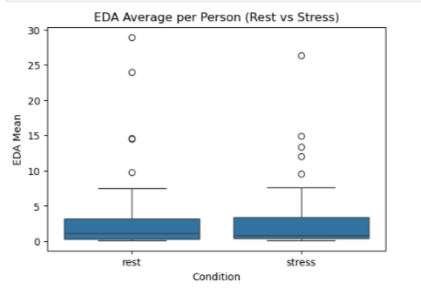

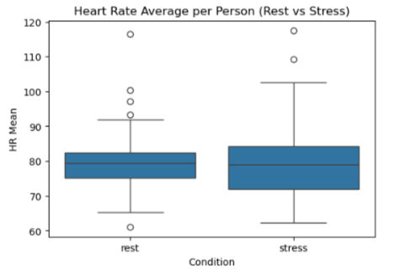

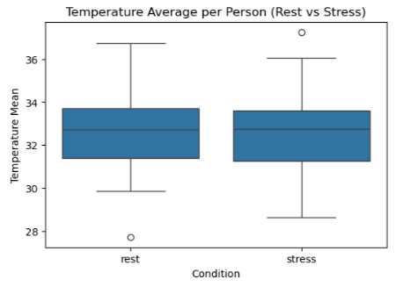

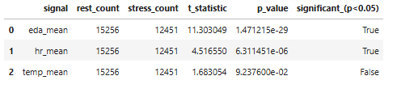

Machine Learning Modelling

After we made the feature dataset, we used machine learning models to figure out when people were resting and when they were stressed. We tried out two models for this project: Logistic Regression and Random Forest. We used Logistic Regression as a model because it is easy to understand and it works well for a lot of classification problems. We also used Random Forest because it is more powerful and can find patterns in the data.

We trained the models using the features we got from the sliding window dataset. We split the dataset into two parts: one for training and one for testing so we could see how well the models worked.
We looked at things to see how good the models were, including how accurate they were, how precise they were how well they remembered things and their F1-score. These things helped us understand how well the models could tell when people were stressed or resting.

The results showed that the Random Forest model was better than Logistic Regression and it was right 80% of the time. We found out that the Random Forest model was really good at figuring out when people were stressed or resting. The feature dataset and machine learning models like Logistic Regression and Random Forest were very important, for this project. To further evaluate the robustness of the model, we also tested it on an external dataset. The results showed a significant drop in performance, indicating that the model may not generalise well to different real-world conditions.

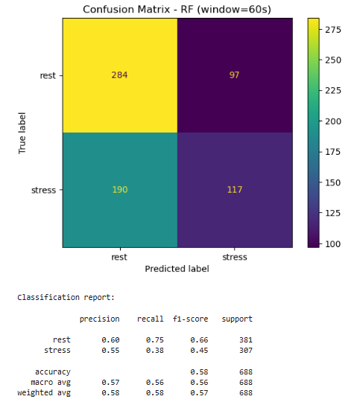
External Dataset Validation

To evaluate the generalisation ability of our model, we applied it to an external dataset: the Nurse Stress Prediction dataset. This dataset contains physiological signals collected in real-world hospital environments, which differ significantly from the controlled experimental conditions of our original dataset.

The nurse dataset includes similar physiological signals such as electrodermal activity (EDA), heart rate (HR), skin temperature (TEMP), and accelerometer data (X, Y, Z). This made it suitable for testing our existing pipeline without modifying the feature extraction process.

We applied the same preprocessing steps, including sliding window segmentation (10, 30, and 60 seconds with 50% overlap) and statistical feature extraction (mean and standard deviation). The trained Random Forest model from our original dataset was then used to make predictions on this new dataset.

Results showed that the model achieved an accuracy of 0.0 on the nurse dataset. This indicates that the model did not generalise well to the external data.

There are several reasons for this performance difference:

• The original dataset was collected in a controlled environment, while the nurse dataset represents real-world conditions with more noise and variability.
• The nurse dataset contained mostly stress-labelled samples, leading to class imbalance and unreliable evaluation metrics.
• Differences in sensor conditions and participant behaviour affected the physiological signal patterns.
• The model may have learned patterns specific to the original dataset and struggled to adapt to unseen data.

This experiment highlights the importance of testing machine learning models on external datasets. It shows that high performance on one dataset does not guarantee good performance in real-world scenarios.
Challenges Faced

During the project we faced challenges. One of them was aligning signals with sampling rates. Each physiological signal had a recording frequency so we had to process them carefully to ensure the signals were synchronized correctly.

Another challenge was handling incomplete tag files. Some participants were missing stress tag timestamps so we had to add checks in the code to prevent errors during processing. We had to deal with missing stress tag timestamps.

We also had a challenge with implementing sliding window segmentation. We had to calculate window sizes and step sizes to ensure that the windows covered the physiological signals correctly. The window sizes and step sizes were crucial, for the sliding window segmentation.

Skills Developed

This project was really helpful for me to learn things. I got to know more about Python programming and how to work with time-series data. I also learned about feature engineering, statistical analysis and machine learning.

The project was great because I got to work with signals and data from wearable sensors. I learned a lot, about this kind of data and how to use it.

The project also taught me how to work with people. I had to talk to my team members and work together to get things done. We all had jobs to do and we had to make sure everything worked well together. This project really helped me with teamwork and communication skills. The Python programming and machine learning skills I learned were also very useful.

Conclusion

This project successfully developed a stress detection system using wearable sensor data. The pipeline included preprocessing, feature extraction, statistical analysis, and machine learning modelling.

The results showed that physiological signals such as EDA and heart rate are useful for detecting stress, with the Random Forest model achieving approximately 80% accuracy on the original dataset.

However, when the model was tested on an external nurse dataset, the performance dropped significantly. This highlighted the challenge of generalising machine learning models to real-world data collected under different conditions.

Overall, this project provided valuable insights into wearable data analysis, stress detection, and the importance of model validation across different datasets.

